Lab 10: Building a Classroom LAN
Team Members: Francis Vo, Brandon Weber, Myles Sartor, Hanish Vadlamudi

Activity Instructions
The instructions can be found in the Assignment in Canvas.

Questions For Reporting Back
Fill in these questions with the responses that you came up with as a team or that we discussed as a class.
- Submission 1.1: A Screenshot of the client list (one photo per group)
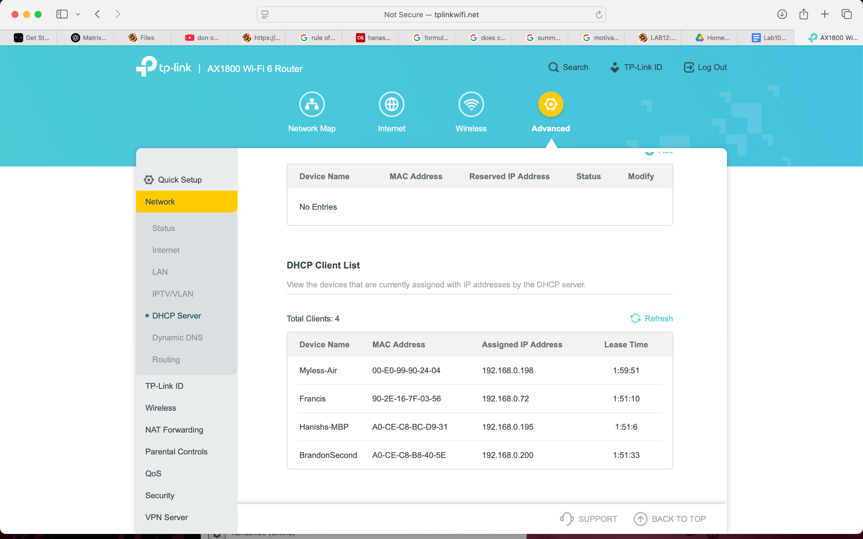

- Submission 1.2: A screenshot of you pinging the web server successfully (one photo per person)
Francis:
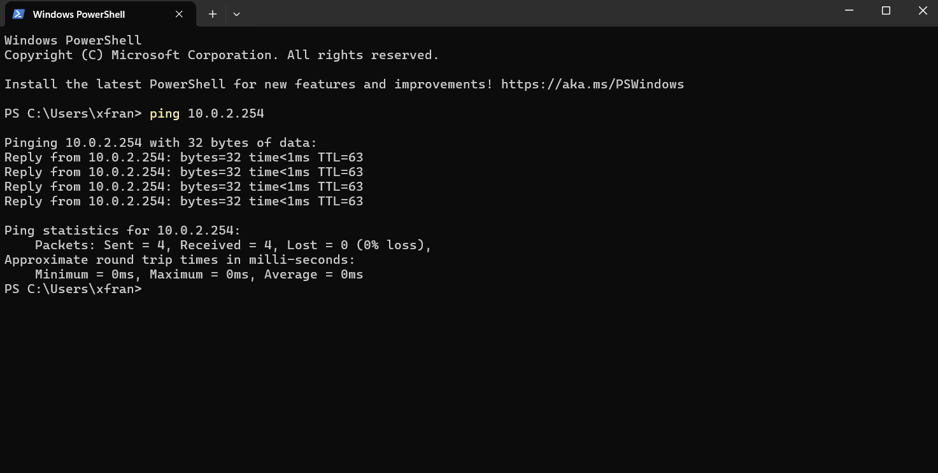
Hanish Vadlamudi: 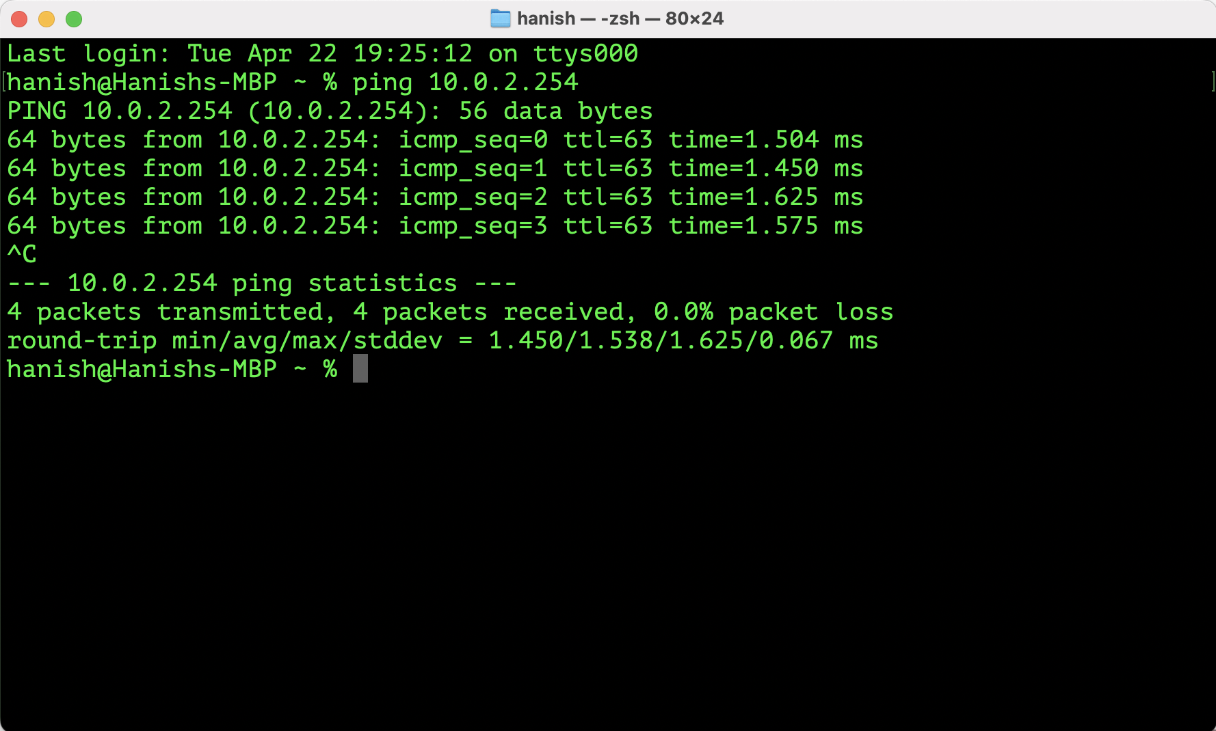

Brandon Weber: 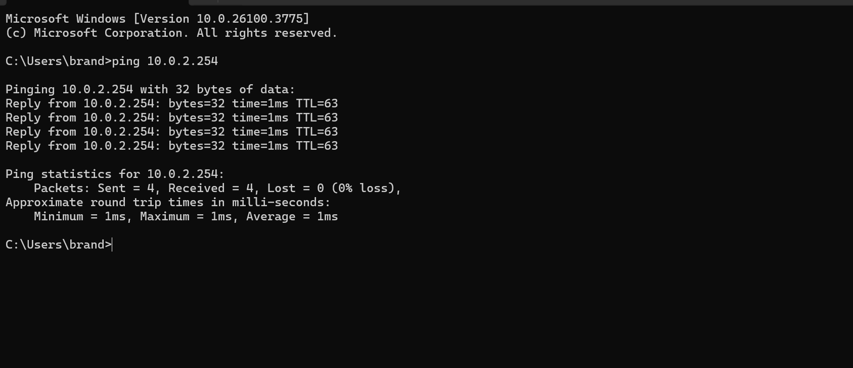
Myles:
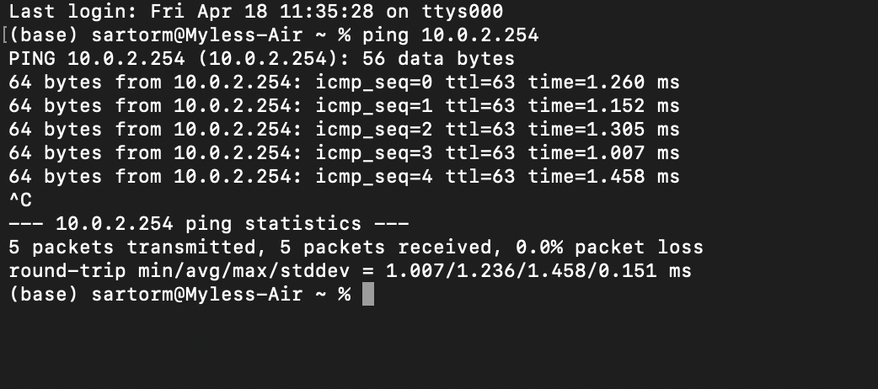
- What IP Address is being seen by the Pi (your router or your computer)? Why?
10.0.2.4 as we are group 4. The ISP sees our whole group as one because we are connected to the router, and there is a router for every team. So the switch (acting as ISP) considers each router its own device connected to its network.

- What is one thing that your team learned by completing the series of networking labs that built up to this larger network?
We learned the little part, such as the ethernet connections from laptops and routers connecting to a larger network (central switch).

